INSIGHTS ADVISE @NVISO, Innovation Park (Lausanne, Switzerland) 2016-2019



THE COMPANY



NVISO ([www.nviso.ai](https://www.nviso.ai/)) is a company based at the EPFL Innovation Park of Lausanne (Switzerland). It provides AI solutions that can sense, comprehend and act upon human behavior using emotion analytics.

One of the applications that was developed internally is Insights ADVISE ([www.nviso.ai/en/insights-advise](https://www.nviso.ai/en/insights-advise) and https://insightsadvisedemo.nviso.ai). It a unique fintech solution that uses AI and an ordinary webcam or smartphone to capture facial expressions in real-time as users watch a video about a variety of financial issues. At the end of the experience, it delivers a personalized report that allows users (investors and financial advisors) to make better financial decisions based on how investors feel about their finances.

It was successfully deployed by the Bank of New Zealand. Over 200,000 people, more than six percent of the country’s adult population, participated. After the project was finished, there were significant improvements: the bank rose from fifth place to second in the national rankings in terms of being considered a good place for clients to manage their money.

THE OBJECTIVE

Insights ADVISOR, previously named EmotionAdvisor, was a Flash-based web application composed of one element called “Experience”. The users could answer a few simple questions about themselves and their priorities and watch a short video while the system captured their facial expressions. At the end the system created their personalized report, which they could either keep to themselves, or share with their advisor.

The objective of NVISO was to take EmotionAdvisor to the next level by providing a more complete fintech solution where companies could manage the data collected from their clients and generate leads. A client (an American company of financial advisors) was interested in investing time, budget and their expertise to develop the product with NVISO.

MY ROLE

I was hired to help NVISO conceive the user experience of the new version of EmotionAdvisor and to manage the project, including interaction with all stakeholders (target users, client, developers, marketing team, graphic designer and so on).

THE TEAM

The project team varied over time but on average it was composed of a graphic designer, eight developers, one QA, three marketing, a technical project manager and myself. Most of the team was working remotely. I was the only one responsible for the UX aspect. Only few people knew a little what UX design is about.

THE APPROACH

To accomplish my tasks, I put in place the User-Centered Design (UCD) process in Scrum methodology with the help of JIRA management tool.

User Research

I began the project when the clients and NVISO had already some ideas on the needs and features the new version of EmotionAdvisor had to have. The first phase was mainly discussions with client and some target users about the features to add. We had multiple conference calls and whiteboarding sessions.

Final target users were clients (investors), financial advisors and the financial companies (such as banks, financial advisor groups, insurances and so on).

After going through all of their feature requests, we were able to identify their most important needs and could finally define the use cases, scenarios and user flows which were used as the reference to focus and develop features.

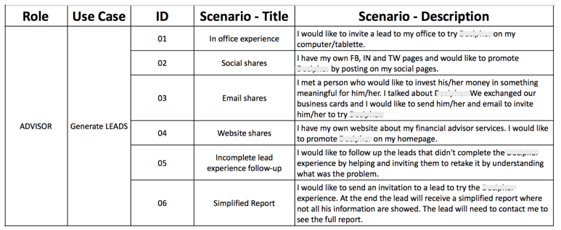

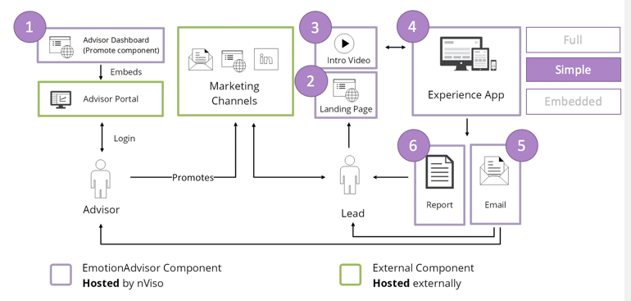

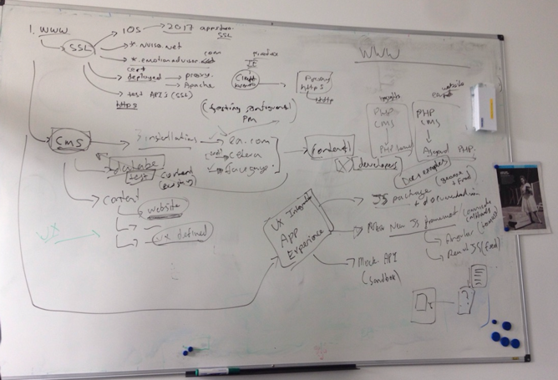

Prototyping

From the previous findings I began to create wireframes and prototypes with MS Visio, Sketch, Adobe Suite, InVision and proto.io. As I was constantly in contact with each stakeholder, I was able to create a proposal that considered each aspect: business requirements, as well astechnical feasibility and limitations. The wireframes/prototypes were the visual basics where we could begin the discussion and that made sure that each stakeholder was on the same line.

Here some examples:

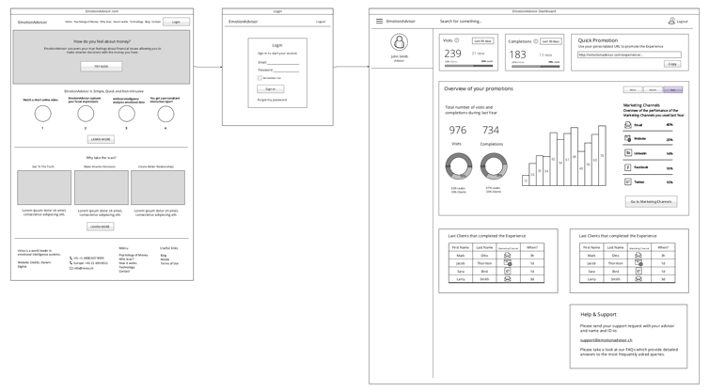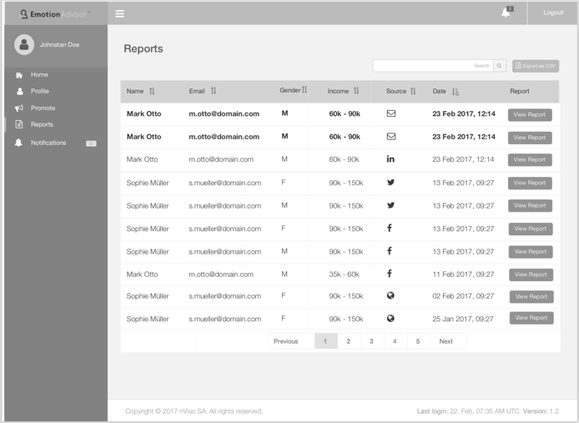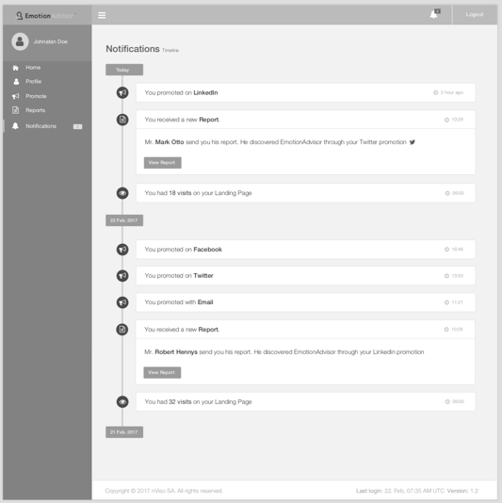

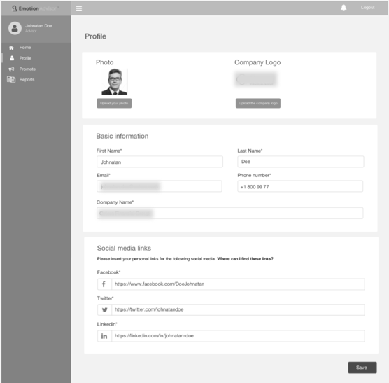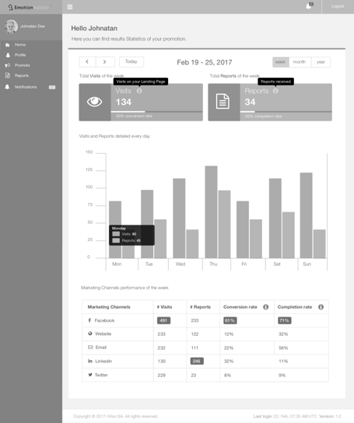

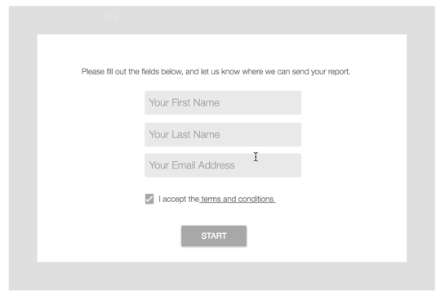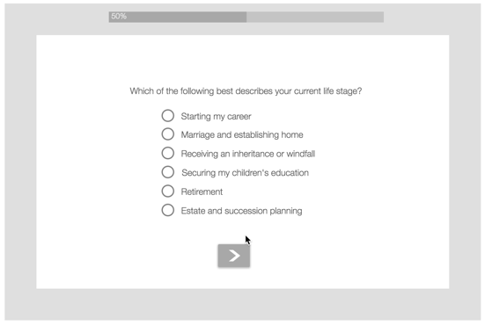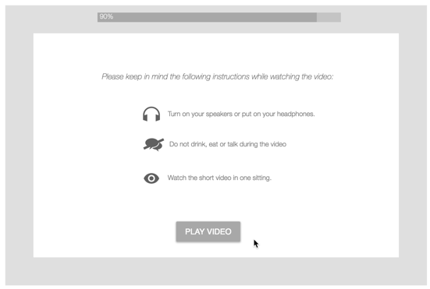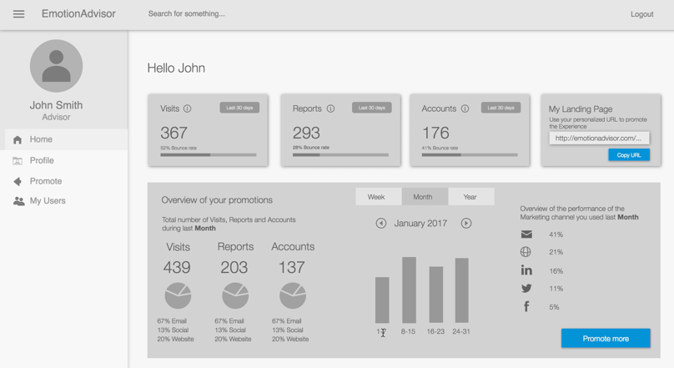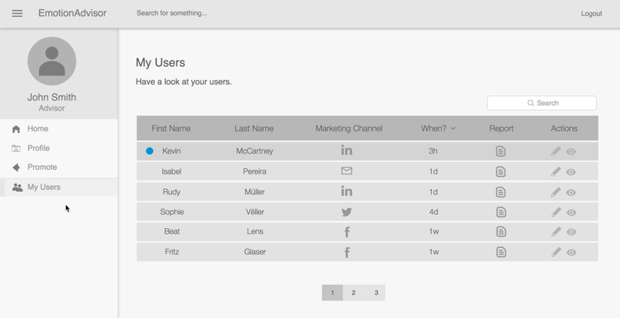

User Evaluations

I organized multiple user evaluation sessions in different ways such as remotely, in a bank and in the office. The user flows were tested by the target users with clickable prototypes created in proto.io.

Here a small example: *Video*

They accomplished tasks while think-aloud and at the end I asked questions. In this way, I could collect feedbacks which were a precious resource that helped me to improve the prototype for the next iteration.

Development and final product

Each time a prototype was agreed, I had contact with the graphic designer who created a pixel perfect PSD file (Photoshop). The latter was part of the package that was transmitted to the developers along with the specifications of it. Before they began to develop, I made them a presentation of the whole piece of system that they were about to develop to make sure they understood what was required. Then, during the development, I was in regular contact with them to answer questions and make a clear and neat description before they dived into the details.

Here some screenshots of the final product:

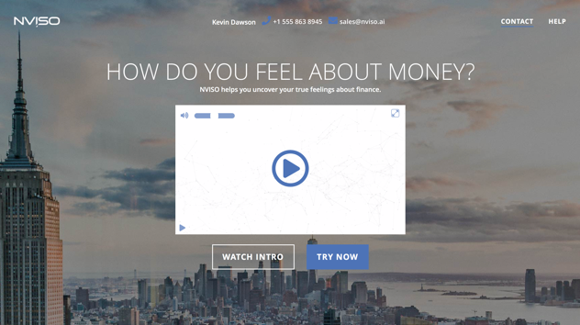

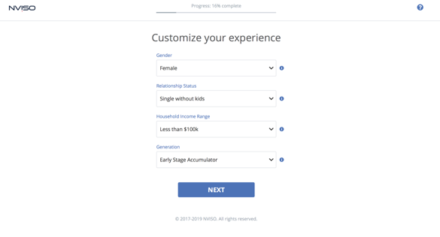 

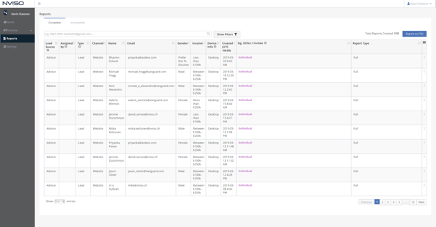

OUTCOME  
EmotionAdvisor upper version is now called Insights ADVISE (https://insightsadvisedemo.nviso.ai). It has additional components other than the initial “Experience”: Dashboards, Landing Page, iOS app, Email and multiple Reports. It is currently ready to be deployed and used by the members of the American company that invested in its development.

LEARNINGS

In this project, a big challenge for me was to be sure that UX design was considered and accepted by the other members of the team as they had never had occasion to include it in their projects in the past. They cared about the project as much as I did and they wanted to be convinced about what everybody’s efforts actually contributed to the product. It took some months of concrete examples to convince the team about the positive impact of UX. This motivated me to make more efforts, to be humble and confident. Furthermore, it was a good exercise before pitching to the other stakeholders such as the client, sometimes not convinced about proposals that were different from what they expected. Thanks to the concrete arguments found from users’ feedbacks, we could easily find a solution that fitted for all parties.

One key learning is always using visual representation of what I am talking about. only in this way could the discussion with multiple people (meaning different personalities, point of views, brains, experiences, roles,…) be efficient and productive.

Furthermore, working for NVISO allowed me to develop some skills that are related to my personality and my work attitude. In fact, thanks to my social and communicative nature and to my technical knowledge, I could efficiently collaborate with people that have different job positions than mine such as developers, graphic designers, QA, marketing, and also with clients with whom I also practiced presenting and defending my proposals.

Last but not least, with NVISO I had also the great opportunity to go to Dubai (United Arab Emirates) where I could help the marketing team develop the business in the Middle East, while at the same time keep on developing Insights ADVISE.

